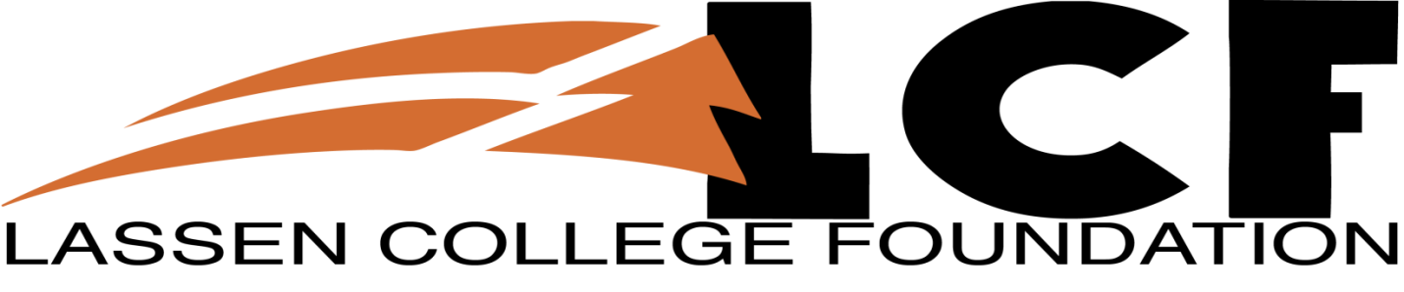
The Lassen College Foundation supports the Lassen College mission of providing outstanding programs for all those pursuing higher education goals through student scholarships, support and advocacy.

Board Meeting Agenda
Monday, August 5, 2015
6:00 P.M.
Lassen College Board Room

- Call to Order:
- Pledge Of Allegiance:
- Roll Call:
Board Members:
Mike O’Kelly, President
Sophia Wages, Vice-President
Maria Nye, Secretary
Dave Clausen, Treasurer
Aaron Dixon, Member
Todd Eid, Member
Gary Felt, Member
Dr. Marlon Hall, Lassen Community College President
Bill McCabe, Member

Directors Emeritus Members:
Richard St. Peter
Rocky Deal
Gino Surian
Marian Liddell

Visitor:
Scott McCullough, Lassen Cougar Enterprises -Present

- Approval of the Agenda(action/information item)
- Approval of the Minutes(action/information item)

- Public Comment:

- New Business(action/information items)
  - Annual Reports(action/information item)
  - Adopt Strategy Map Formally(action/information item)
  - Board Nominations(action/information item)
  - Library Request for Student Incentives(action/information item)

- Old Business(action/information items)
  - Annual Plan and Budget(action/information item)
  - Three-year plan and Cash Projection(action/information item)
  - Vision and Mission Statement(action/information item)
  - Title III Update(action/information item)
  - Board Training(action/information item)

- Reports
  - LCC President’s Report
  - Cougar Enterprises Report
  - Resource Development Specialist Report
  - Alumni Association Report(form Alumni and Friends Committee)
  - Other items to discuss

- Items to Discuss At Next Meeting

- Next Meeting: September 7, 2015

- Adjournment

