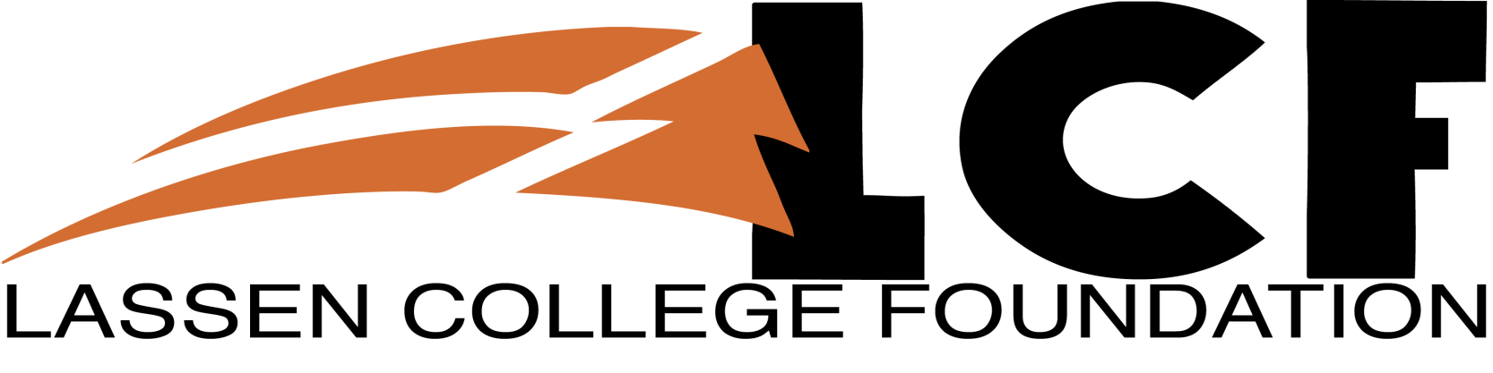

Ways of Giving

There are many ways in which to give a gift to Lassen Community College. Any amount is appreciated and will be used as the donor requests and in accordance with the Foundation’s bylaws.

**Creating an Endowment:** You can establish a lasting gift by creating an endowment to fund scholarships, equipment, or professional development. To learn more about creating endowments please contact the Lassen College Resource Development Department/Foundation at (530) 257-6181 x8913 or send an Email to lcfoundation@lassencollege.edu.

**Major and Capital Gifts:** These gifts are used for specific, pre-determined college priorities and provide the donor with an opportunity to permanently link a family or company name with the life and work of Lassen Community College.

**Gifts of Securities and other Appreciated Assets:** A gift of appreciated assets such as stocks may have significant tax benefits for a donor. Donors may wish to consider donating securities outright or an IRA or a 401K to the Lassen Community College Foundation as part of their estate planning as well.

**Gift of Property:** The Lassen Community College Foundation also has the ability to accept certain real and personal property.

**Gift of Cash:** You can make a cash donation through the Resource Development Department/Foundation located in the Administration Building at Lassen Community College.

**Donate to a Specific Purpose:** You can specify the cause to which you wish your donation to be applied.

**Donate by Mail:** You can donate through the mail by sending a donation form and check to:

Lassen Community College Foundation P.O. Box 3000 Susanville, CA 96130

**Donate Online:**

The easiest way to give is through an online donation using your Visa, MasterCard, or Discover Card. You may direct how you wish the donation to be spent or you can have it go to the area of greatest need. You may also set up a recurring donation. Click the box below to access *PayPal* and make a secure donation.

 

**All inquiries are confidential and without obligation. Please check with your financial advisor to see which gift is best for you.**

***Remember - Donations are 100% tax deductible!***